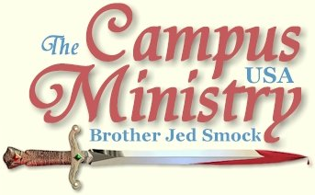
BROJED.ORG
brojed@aol.com
Cell 573-999-0347
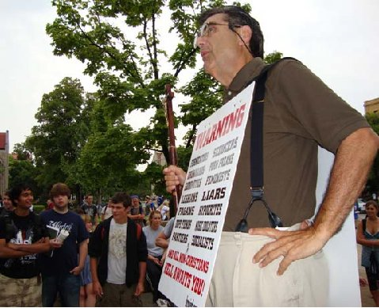
Kansas University

Note from Sister Cindy:
Hello Dear Saints of God,
My husband arrived home from Ghana, West Africa at about midnight on Saturday, August 22, and at noon on Monday the 24th he was at his post at the University of Missouri. He left for campuses in Kansas and Colorado on Wednesday. I am amazed and thankful for his commitment to proclaim the gospel to the lost. If you did not have time to read all four of the Ghana reports, please take time to read the last one that I sent out which includes his visit to the campuses in Ghana and his reflections on the mission trip. When my husband made plans to go to Ghana, he did not ask me if I thought that it was a good idea; if he had, I would have said, “No!” (Because he has never done well on foreign soil.) I guess there are times that even the best of wives should keep their mouths shut! I am so glad that he and Charlotte did go and I am grateful for the mighty way that God worked.
We can’t thank you our supporters enough for your commitment to the Lord’s work through us. A new school year begins and there are multitudes on the paths of destruction that need to be compelled to consider their ways and hear the glorious gospel of Jesus Christ. Below, I have pasted some info from our July snail letter that lists ways that you can help us. (Since many of you do not get that letter) Bro. Jed’s Journal follows.
What can you do to help?
1. As the school year begins we need faithful prayer warriors to intercede for souls as well as praying for our health, safety and financial needs. This is vital!
2. As always, we need monetary gifts. We appreciate that some of your budgets are considerably tighter and yet you have continued to give faithfully. May God reward your generosity. Some have had to reduce your giving significantly, but you are still donating what you can. Thank you also. Please know that no gift is ever too small. God accepts them and so do we. If more of you would just send small gifts, it would help us greatly. If any of you do have extra funds and can make up the slack, please do so. We are also trying to find ways to reduce our own budgets. Often saints provide lodging for us when we come to their campus town. If you would like to help in this important way please contact us.
3. Arranging a church or home meeting is a great way to bless the CMUSA. Bro. Jed welcomes the opportunity to meet and minster to new people. He is thankful to address groups both large and small. It is amazing the hearts that God will touch in just a small home meeting. I believe that there are many Christians who would like to support this work on the campuses if they knew about it. Help us get the word out.
4. Finally, invite your friends to receive this journal also. It will make Christianity come alive, increase their faith and keep them revived!
5. Also, if you haven’t read Who Will Rise Up? lately, I encourage you to do so. If you gave your copy to someone and never got it back, you may order a new one from us for a $12 gift to CMUSA. We found a few extra boxes.
You may donate to CMUSA using PayPal by going to our website at Brojed.org or you may mail a check to our home office: CMUSA, Bro. Jed smock, 2402 Longview Dr. Columbia, MO 65203
In Christ, Sister Cindy Smock
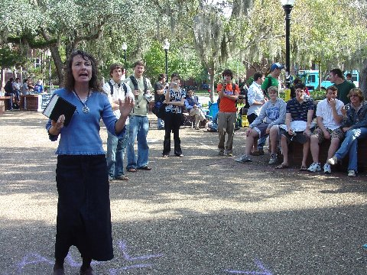
AN OVATION
By Bro. Jed
University of Missouri, August 24, 2009, I received an ovation from students when I walked into Speakers’ Circle and several walked up to shake my hand. The college radio station played amplified music over the noon hour. I tried to speak above it; but I finally decided to wait until the music stopped. Eventually, students started asking me economic questions and raised issues concerning Obama care. I built up the crowd to about 75 by the time Cindy arrive. She was able to almost double the crowd.
I talked to Dr. Acuff on the sidelines; and told him that he could speak after Cindy. Cindy called on him about 3 PM to address some issues concerning evolution that the students were asking. But Dr. Acuff went off in another direction. Several Christians cornered Cindy after the preaching complaining about her methods and message. We left Speakers’’ Circle in the able hands of Dr. Acuff at 3:30 since we had a lot to do after being away from home for three weeks.
SIGNS FOLLOWING
University of Missouri, August 25, 2009, I received in the mail yesterday afternoon some new signs which Bible Jim Webber had made for me since I had left all the signs I had in Africa. I wore a sandwich board sign on campus which on the front warned the students concerning various sins that would condemn their soul for eternity. On the back the sign read, “FEAR GOD, TRUST JESUS.” It is humbling wearing a sandwich board sign; but it does get the attention of the students. I would prefer holding a sign; however, the sandwich board is less likely to get stolen and it frees my arms to hold a Bible in one hand and my staff in the other. I preached to an average crowd of 50 students until 4 PM.
A NEW VOICE
Kansas University, August 26, 2009, Allen Stancil, who pastors and intercity church in Kansas City joined me on campus. Pastor Stancil was inspired to go into the open air after I held a revival in his church this summer.
On August 19 Pastor Stancil emailed me, I went to the corner of Independence Ave & Hardesty Ave during rush hour Tuesday with a new sign "Repent, Jesus is Coming Soon" I held it with my left hand and my Bible in my right. It clearly got more attention than only holding up my Bible.
Today I plan to use "SEX Outside Of Marriage Is SIN" & tomorrow “REPENT & Believe In The LORD JESUS CHRIST” (My granddaughter Liz painted these for me).
Some might think this is extreme but I believe I have a Biblical basis for this: “And he said unto them, Go ye into all the world, and preach the gospel to every creature. Mark 16:15”
August 20 I received a follow up email from Pastor Stancil:
I went back out at Independence Ave & Hardesty Ave again during Wednesday rush hour to show “SEX Outside Of Marriage Is SIN.” I received a “few thumbs” up and “amen’s” and lot of laughing, ridicule, lewd gestures.
One big man crossed the street walking directly towards me with a scowl on his face and fists clinched staring right at me. I could see the anger in his eyes. I thought surely he was going to attack me, but he walked by so close nearly brushing against me. A girl that looked about 18yrs old yelled from her car “Doesn’t everyone already know that?” (Referring to my sign) I told her “No. Everyone doesn’t know”. The truth is everyone does not know that sin is opposition or hatred towards that which God loves. Others yelled insults made gestures with their tongues.
I knew this sign would be offensive as most preachers won’t preach against it any more. Neither do they preach against gambling and booze.
At KU, I immediately, I gathered a crowd of a few hundred. They were quite stirred. I think the sandwich board sign was pricking their hearts. One fellow ran off with my chair; but I chased him down and was able to recover it. After that he stood on the wall beside me. At one point he feigned falling off the wall; and as he did, he intentionally spilled his drink all over me.
After an hour I decided to throw Pastor Stancil to the wolves. He had never been in a situation like this; but I had confidence he could handle it. I was glad to get a little break since my session had been quite intense; and I am still recovering from jet lag, etc. from my African mission. He spoke boldly for almost an hour before calling up me again.
Meanwhile, three policemen showed up to monitor the situation, which had little effect on settling down the crowd which at times reached at least 300 students. The moral issues were paramount throughout the afternoon. I gave Pastor Stancil second opportunity to speak. We stopped at 4 PM. For the last hour the students were more settled as I preached and during this time Pastor Stancil had a group of 6-10 around him.
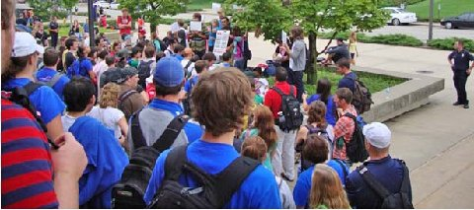
Police Arrive
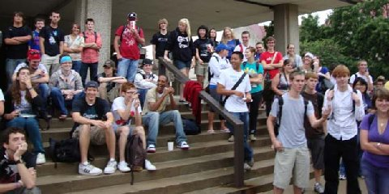
The Crowds are Stirred!
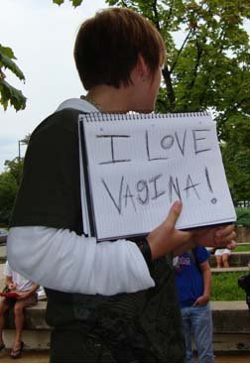
A Vulgar Girl
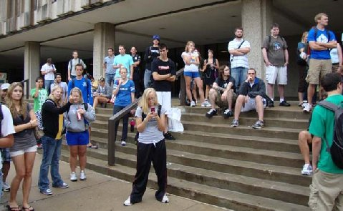
Notice the Cell Phones
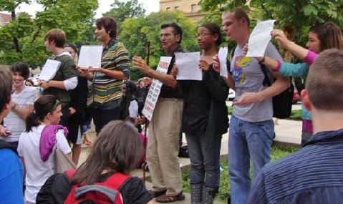
The Heathen Rage
END TIMES HANDMAIDEN
Kansas State University, August 27, 2009, Bonnie B. and her husband hosted me in Manhattan. Bonnie is a member of the End Times Handmaidens organization. She is a vocal and bold witness for Christ wherever she is. She accompanies me to campus whenever I am at KSU.
When I started preaching students slowly gathered. There was a crude and very obese smoker, who was confined to a wheelchair (I suspect that he was too heavy to walk), who boisterously began complaining about my preaching. He claimed to be a Christian, all the while cursing. He finally called the police to complain about me. The policeman must have lectured him on my first amendment rights.
Meanwhile about one hundred students had gathered. I must have preached to them for about 30 minutes before they started responding. Eventually, they crowded around me and became quite vocal. I called upon Bonnie to speak. She has a prison ministry. When she told the students a doctor came to the prison and warned the prisoners that AIDS could be communicated through the finger nails, one effeminate type, who said he had AIDS and held AIDS awareness seminars, became quite irate. When Sister Bonnie told him that God could heal AIDS, he became beside himself. He became angrier when Bonnie said, “With your attitude God will not heal you.”
At one point when Bonnie was speaking, the policeman told me I would have to hold it down since there were complaints coming from the classrooms concerning the noise. When holding things down, one usually loses some numbers. On the other hand it can be profitable when the students are more settled.
Before I had started preaching, I listened to a fellow in a wheel chair named John witnessing to a student. At the time I thought to myself he is going to be trouble for me today. I could tell from his witness that he was longwinded and did not give the person he was talking to an opportunity to respond. He finally told the student to whom he was testifying, “You can talk to me anytime. I am easy to find because I am in a wheel chair and I am black.”
Sure enough, after I had been speaking for an hour John wheels himself into the center of the crowd and wants to take over. What can you do when someone is in a wheel chair? He had the standard evangelical message of sinning Christianity. I think that he meant well; but a few times I had to interrupt. At one point, he said, “I am going over a here a piece to tell you about real Christianity.” The crowd followed him; but, as always, sinning Christians cannot hold the attention of the students. Soon they all come back to hear the message of holiness, including John.
I left campus at 3:30 since I had a four hour drive to Colby, KS, where long time friend and street preacher, Scott Crawford, always provides for me a room in his motel.
Colorado College, August 28. This is a small private liberal arts school in Colorado Springs. I knew that classes did not start until Monday; but I hoped that there would be enough people around that I could get some attention. After about 15 minutes of wearing my sandwich board and occasioning making some comments, a friendly security officer told me that only the athletes were on campus. The freshmen were on a retreat and the other students would be coming in on Saturday and Sunday. I decided to stop preaching and check in my hotel. I am holding a tent crusade for Victory World Outreach over the weekend.

Revival?
Another Note from Sister Cindy:
(From our snail letter)
Over the summer our family re-read Bro. Jed’s autobiography, Who Will Rise Up? When the first edition was written in 1984 there were only a few campus preachers. One purpose of the volume was to challenge more to go forth with God’s Word.
WWRI? includes the following quote from John Wesley, “Give me one hundred preachers who fear nothing but sin and desire nothing but God, and I care not a straw whether they be clergy or laymen; such alone will shake the gates of Hell and set up the Kingdom of Heaven on earth.” In the last 25 years many have heard God’s call to take the Gospel to America’s college students. Numerous men and women (there are several husband and wife teams) have given up careers, homes and money to follow the example of the Methodist circuit riders and “warn men to flee from the wrath to come and be saved from sin.”
Wesley wrote in his journal, “At seven I preached at the Gins and the people flocked together from all quarters. The want of field-preaching (outdoor) has been one cause of the deadness here. I do not find any great increase of the work of God without it…”
Both Wesley and Spurgeon believed that open-air preaching was a catalyst for revival. With all the new Holy Spirit anointed preachers that have come forth in the last few years, we think, now is the time for the revival for which we have long hoped and prayed!
As Bro. Jed begins his 36th year of campus preaching on August 24th, we ask that you the saints of God join with us in believing for a mighty move of God’s Spirit, a huge harvest of souls and a righteous revival of truth.
Bro Jed wrote 25 years ago in the second edition of his biography, “I anticipate continuing in the work to which God has called me until I draw my last breath. How could I stop or even slow down when hundreds of thousands of students are rushing madly toward the everlasting torments of Hellfire?”

